EXPERIMENT 9

9.1.1 Count vowels in string

Algorithm:
Step 1: Start
Step 2: Input a string from the user and store it in a variable str
Step 3: Initialize a variable count and set it to 0
Step 4: Take each character from the string one by one
Step 5: Check if the character is a vowel (A, E, I, O, U, a, e, i, o, u)
Step 6: If the character is a vowel, increment count by 1
Step 7: Repeat Steps 4 to 6 until all characters are checked
Step 8: Print the value of count
Step 9: End

Flowchart:
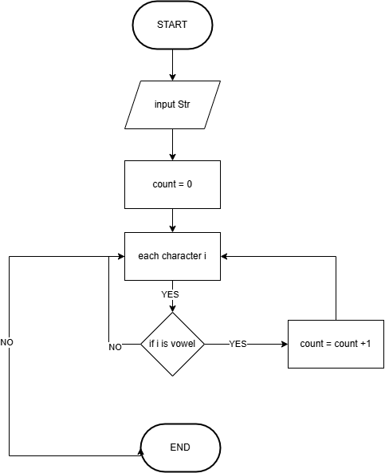

Code:
str = input()
count = 0
for i in str:
if i in ['A', 'E', 'I', 'O', 'U', 'a', 'e', 'i', 'o', 'u']:
count += 1
print(count)

Execution:
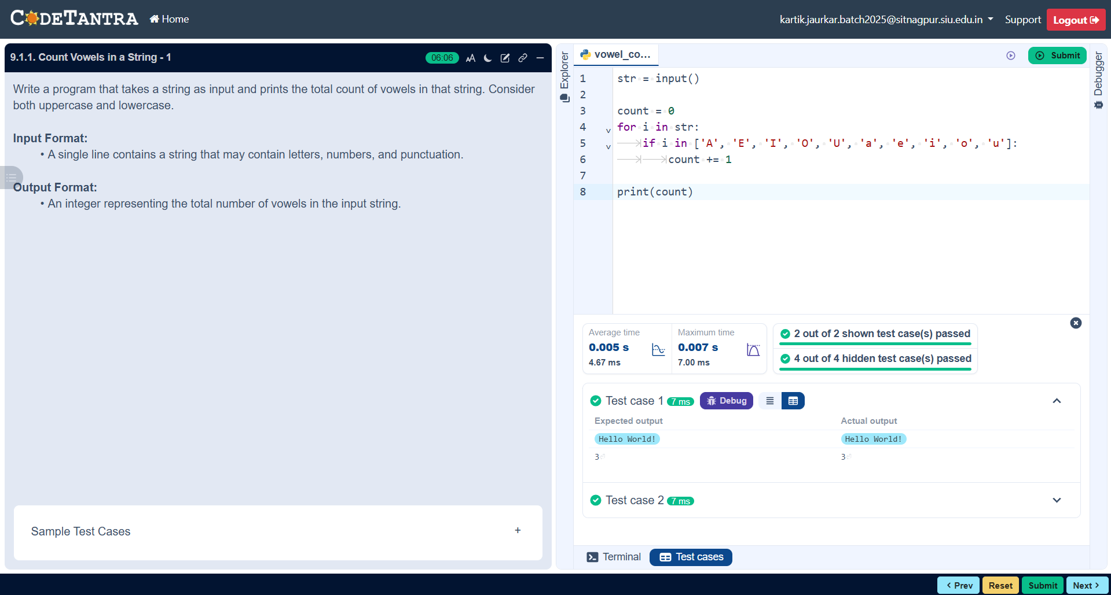

9.1.2 Palindrome or Not

Algorithm:
Step 1: Start
Step 2: Input a string from the user and store it in variable st
Step 3: Find the length of the string and store it in variable l
Step 4: Initialize a variable flag and set it to True
Step 5: Start a loop from index 0 to l-1
Step 6: For each index i, compare:
- character at position i
- character at position l - 1 - i
Step 7: If both characters are not equal:
- set flag = False
Step 8: Repeat Steps 6–7 for all characters
Step 9: After the loop, check flag:
- If flag == True, print "Palindrome"
- Otherwise, print "Not a Palindrome"
Step 10: End

Flowchart:
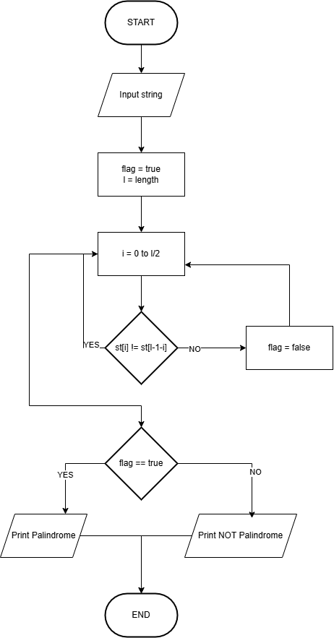

Code:
st = input()
l = len(st)
flag = True
for i in range(l):
if st[i] != st[l-1-i]:
flag = False
if flag;
print("Palindrome")
else:
print("Not a Palindrome")

Execution:
